Functional requirements:
Functional requirements are the primary way that the customer communicates their needs to the team. They keep everyone on the project team going in the same direction. Without an agreed functional requirements document to clearly define the scope, the end product is likely to miss the mark.
Functional requirements define the basic system behaviour. Essentially, they are what the system does or must not do, and can be thought of in terms of how the system responds to inputs. Functional requirements usually define if/then behaviours and include calculations, data input, and business processes.

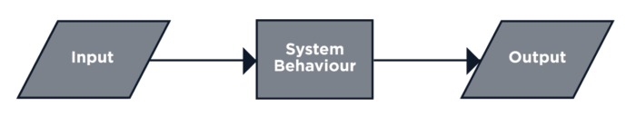

Functional requirements are features that allow the system to function as it was intended. Put another way, if the functional requirements are not met, the system will not work. Functional requirements are product features and focus on user requirements.
The system must provide the following functionalities;
1. Keeping record of admission of customers.
2. Keeping the record of products.
3. Keeping the daily sell.
4. Storing the feedback given by the customer.
5. Keeping details about the product either ithe is delivered or not.
6. Storing the items selected by the customerservice in temporary storage.

Performance of functional requirements:
In order to maintain an acceptable speed at maximum number of uploads allowed from a particular customer will be any number of users can access the system at any time.

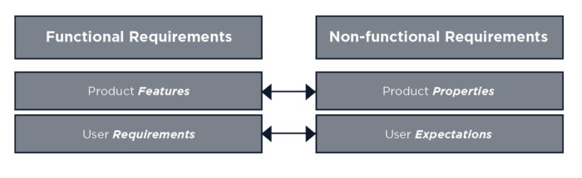

As you brainstorm functional requirements, consider these groups:

. Business requirements.
. Administrative functions.
. User requirements.
. System requirements.

Examples of functional requirements:
. When the user enters the information, the system shall send an approval request.
. The server shall log all changes to existing data.
. When 24 hours have passed since the last database backup, the server shall automatically back up the database.
. The local terminal shall automatically print a list of orders every 4 hours.
. When the local time is 0800, the server shall email a report of open issues to all managers.
. The system shall only allow managers to view customer banking data.

Non-functional Requirements:
Non-functional requirements do not affect the basic functionality of the system (hence the name, non-functional requirements). Even if the non-functional requirements are not met, the system will still perform its basic purpose.
Non-functional requirements are product properties and focus on user expectations.
Following non-functional requirements will be there in the insurance on Internet.
1. Secure access of confidential data.
2. Better component design to get better performance at peak time.
3. Flexible services based on architecture will be highly desirable for future extension.

Various other non-functional requirements are;
. Security
. Extensibility
. Applications affinity
. Resources utilization
. Usability.
. Reliability / Availability.
. Scalability.
. Performance.
. Supportability.

Example of non-functional requirements:

. Database security shall meet HIPAA requirements.
. The layout shall allow users to reach their profile data from any page within 3 clicks.
. If a user has not changed their password for 56 days, then the system shall require a password change upon login.
. The system must accommodate a minimum of 3 million concurrent users.
. All web pages shall load within 4 seconds.
. The server room shall accommodate a future doubling of installed hardware.
. The server room shall be accessible by authorized employees 24 hours per day.
. The background colour for all screens shall be #fff4b6.
. System programming shall not use deprecated code.
, A functional requirement frequently has a related non-functional requirement. Remember that the difference is essentially the what and the how, which are both necessary. Here are some examples: